Lab 12 : Blind SQL injection with conditional errors

**Lab 12: Blind SQL injection with conditional errors**

**Overview**  
This lab relied on triggering database errors to extract information.

**Key Concepts Covered**

* Error-based SQLi
* Using CAST operations to force exceptions

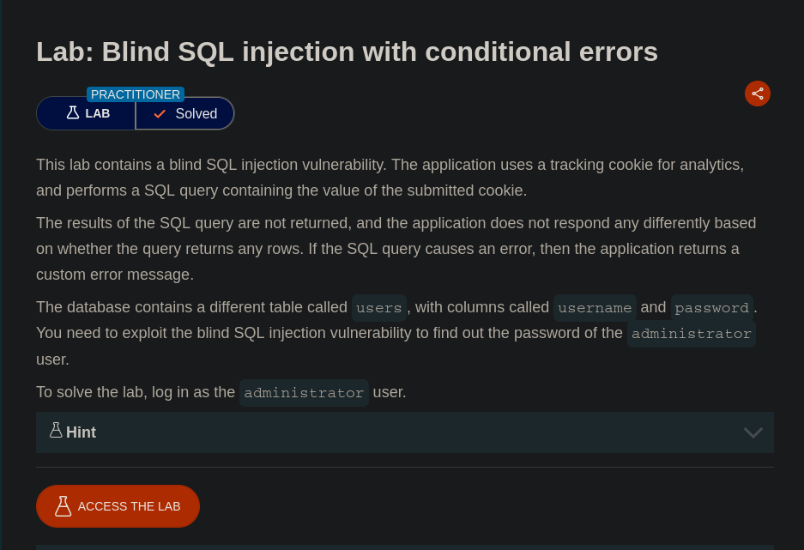

**Completion**

* Difficulty: Hard
* Status: Completed